Welcome back from the holidays! It’s funny to think that while we’re already in 2018, FY18 is almost over. As some people would say, “every end is a new beginning.” Let’s take this time to think about new beginnings and dive into our team’s wins accomplishments this past month. Welcome to the [Customer Experience PCT](https://gus.lightning.force.com/one/one.app#/sObject/0F9B000000008GEKAY/view) newsletter for December, H2 FY18!



**OHANA CULTURE**

*CX Commerce Cloud Sponsored MA Conference for Women 2017!*

Special shoutout to [Idit Vachtel](https://gus.lightning.force.com/one/one.app#/sObject/005B0000000RBe3IAG/view) and [Saya Honjo](https://gus.lightning.force.com/one/one.app#/sObject/005B0000001yDxzIAE/view) for helping organize and coordinate logistics for Commerce Cloud women at the Massachusetts Conference for Women on December 7, 2017, which [Philip Jefferson](https://gus.lightning.force.com/one/one.app#/sObject/005B00000028L2lIAE/view) and [Stefan Piesche](https://gus.lightning.force.com/one/one.app#/sObject/005B00000028L2bIAE/view) helped sponsor.

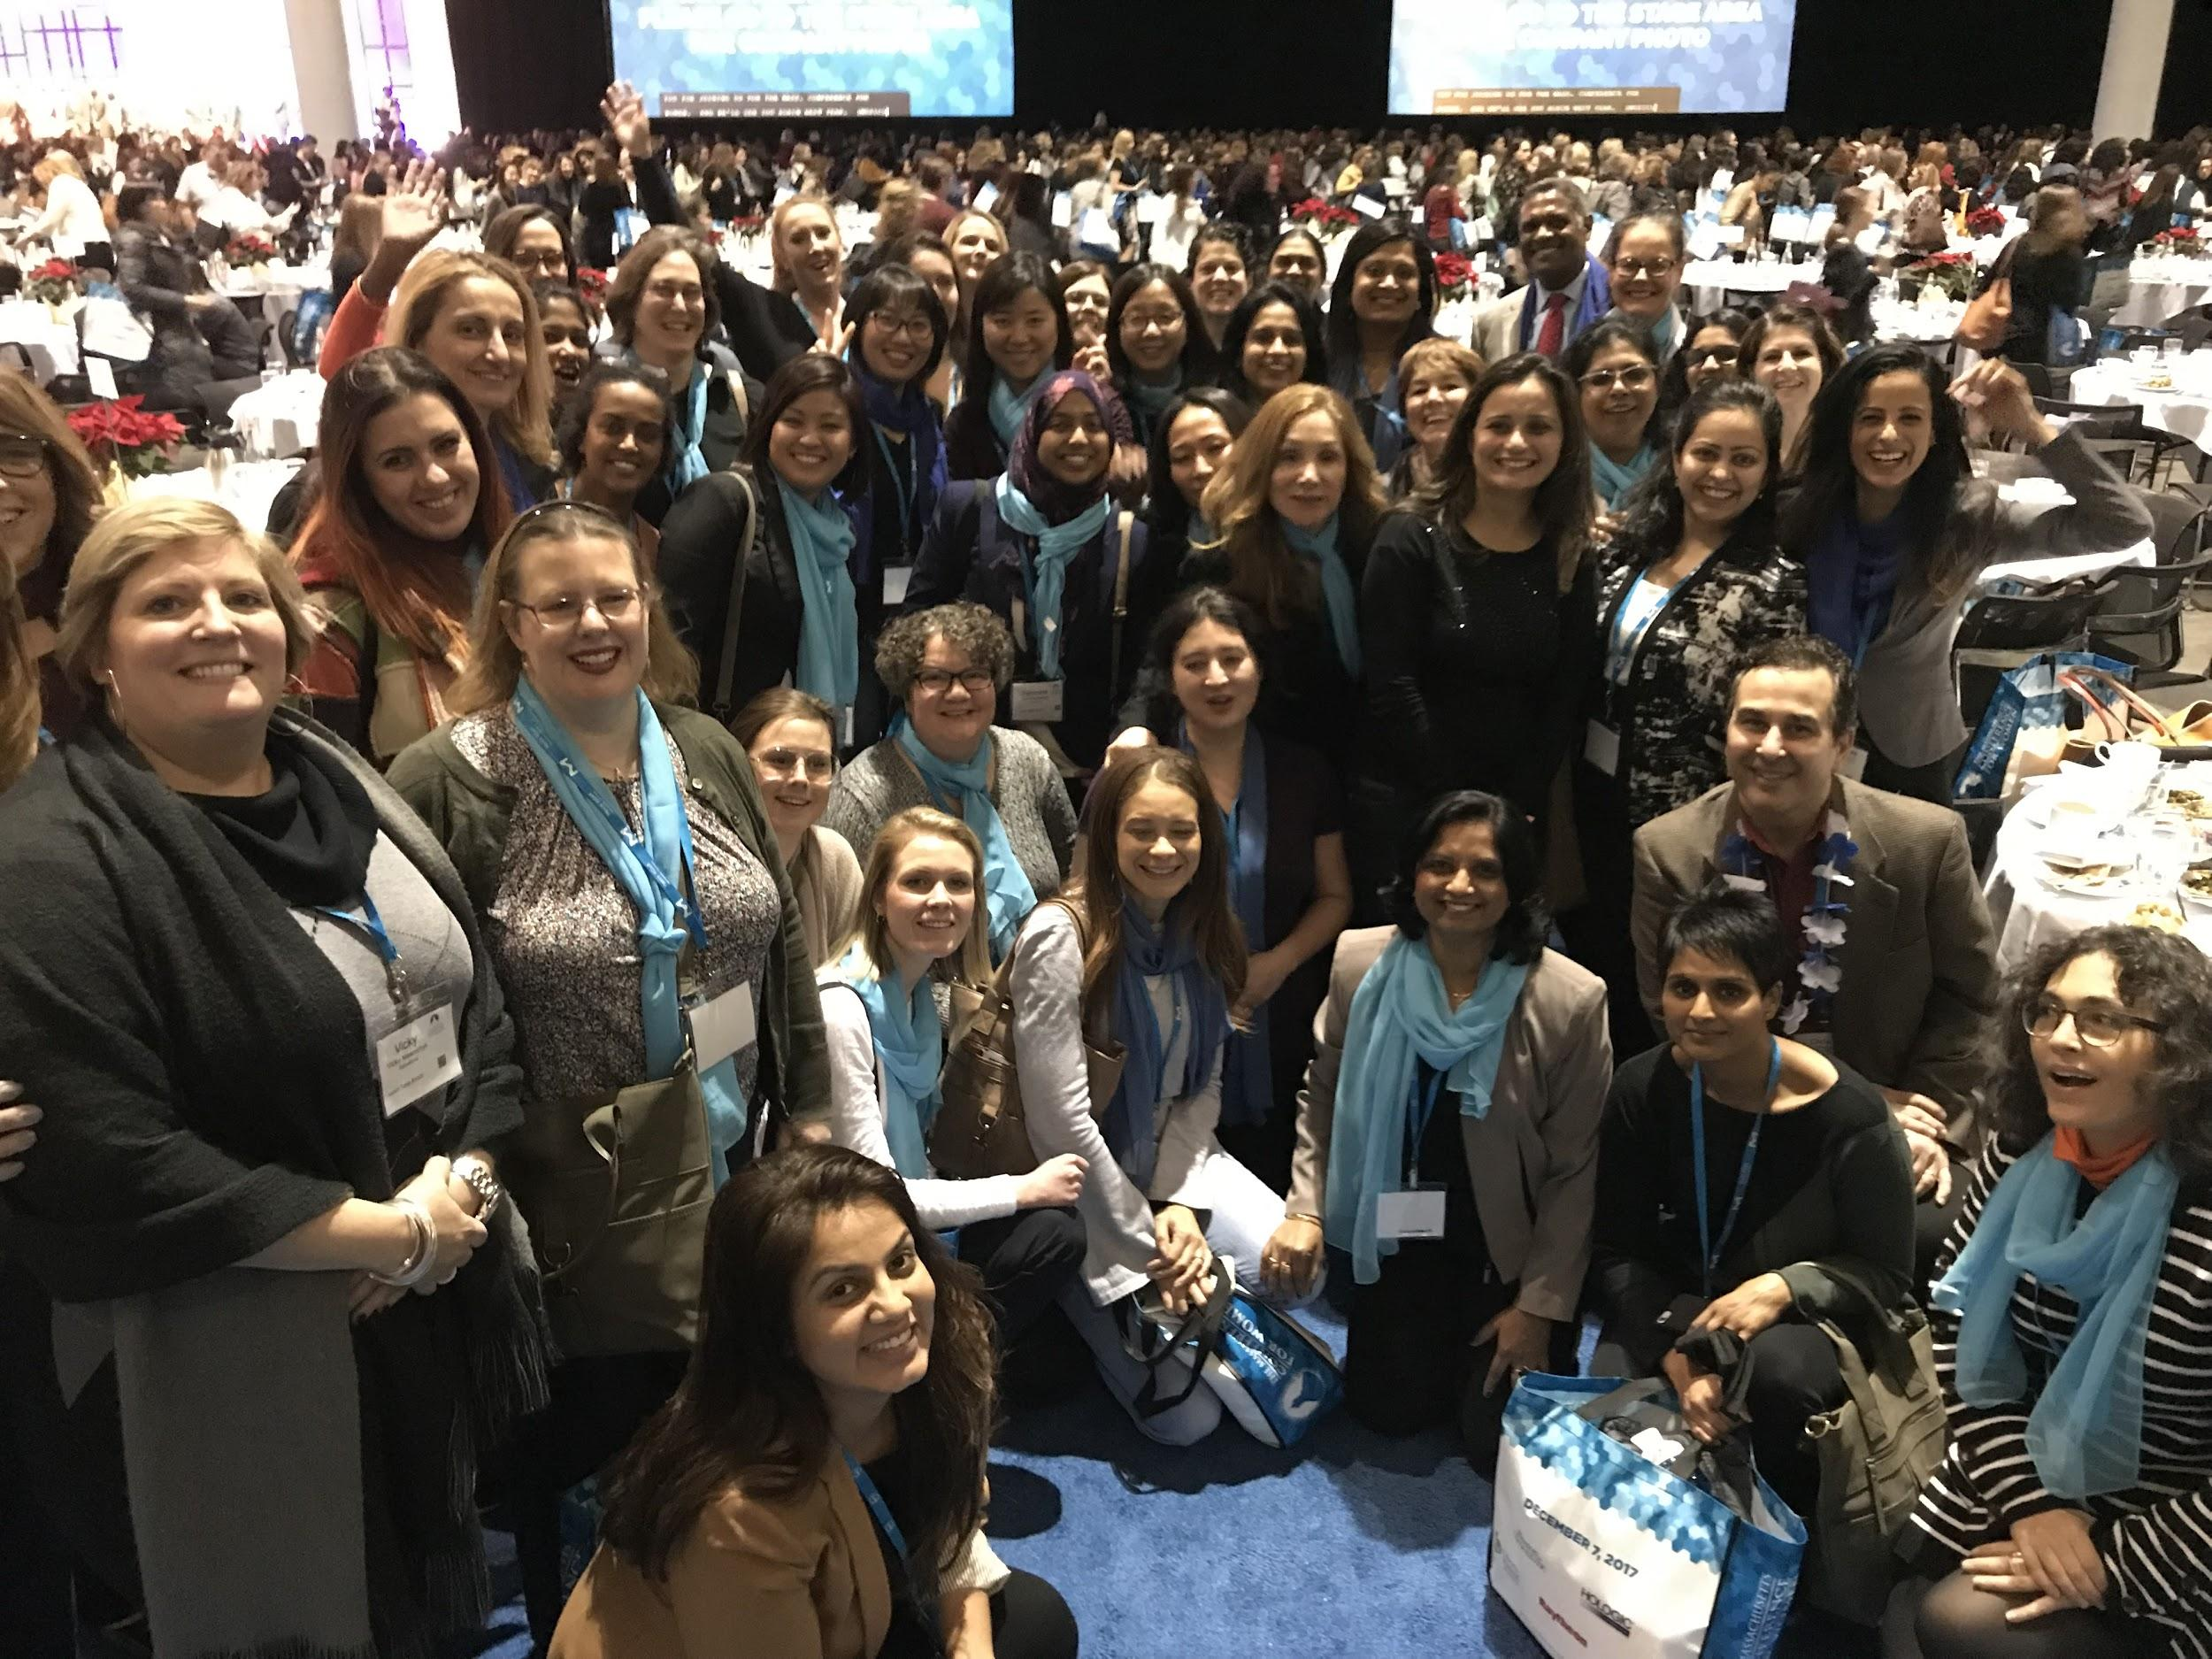

There were over 12,000 attendees and an incredible array of panel speakers, keynote sessions, and roundtables. The Summit Speakers included our very own Cindy Robbins and guest speaker Meryl Streep! This event brought women together to discuss important issues ranging from the workplace to personal issues in everyday life. [Amy Croot](https://gus.lightning.force.com/one/one.app#/sObject/005B00000029o09IAA/view), Senior Program Manager, reminisces that “It was even more special to be there with an enthusiastic group of colleagues from Salesforce.”



Let’s vow to bring gender equality and #WomeninTech motivation into the Ohana Culture discussion for 2018. If you’d like to watch a panel session or read more about the MA Conference for Women, click [here](https://www.maconferenceforwomen.org/videos/)!

*Celebrating Powerful Women: Herndon Netgrrls Gathering 2017!*

Continuing the theme of powerful women, shoutout to [Allison Mankin](https://gus.lightning.force.com/one/one.app#/sObject/005B0000001xBiPIAU/view), [Jami Hoang](https://gus.lightning.force.com/one/one.app#/sObject/005T0000000nC8VIAU/view), and [Pallavi Aras](https://gus.lightning.force.com/one/one.app#/sObject/005B0000000TrydIAC/view), for organizing the first Herndon Netgrrls Gathering to celebrate Ada Lovelace and Grace Murray Hopper’s birthdays! About 12 women from multiple clouds in the Herndon office were present and the team intends to expand with more VTO and networking events in the future.



Quick History Lesson: Ada Lovelace was the first English female “computer programmer” known for her work on designing the Analytical Machine, which had all the essential elements of a modern computer. Grace Hopper was an American computer scientist and US Navy Admiral, who pioneered the Harvard Mark 1 Computer and machine-independent programming languages.

In the vein of Ariana Grande’s song titled “Dangerous Woman,” women have got “nothing to prove and I’m bulletproof, knowing what I’m doing.” Ladylike reacts for all!

**OPERATIONAL EXCELLENCE & AUTOMATION**

*GUS Cases Now Visible in Lightning!*

Thanks to all the work by [Pat Connolly](https://gus.lightning.force.com/one/one.app#/sObject/005B0000000HNZ6IAO/view), Lead Change Manager, and [Paul Christian](https://gus.lightning.force.com/one/one.app#/sObject/005B0000000FnE1IAK/view), SMTS, GUS Cases are now visible on Work Records in Lightning! Shoutout to [Nick McDuffie](https://gus.lightning.force.com/one/one.app#/sObject/005B0000001Z1HbIAK/view), Core Engineering Product Management Director, for the announcement as well.



With the adaptation of GUS Lightning, we are helping our new Ohana in Commerce Cloud to integrate more smoothly.

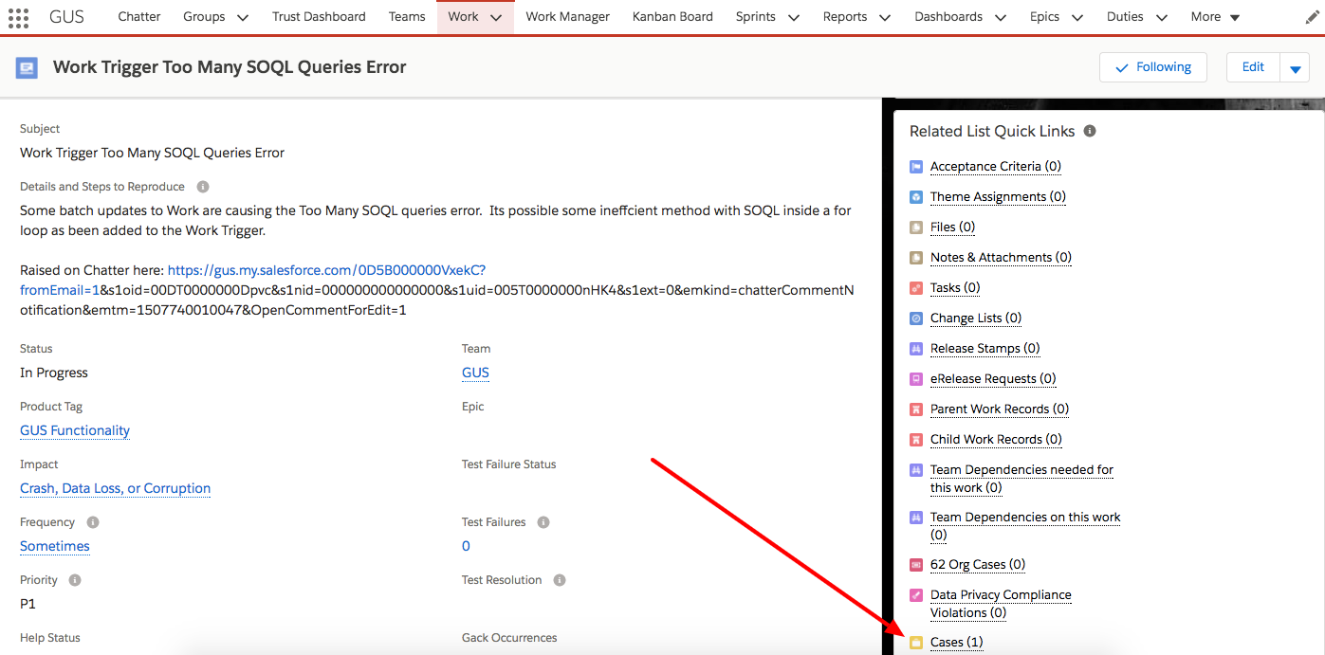

Are you up to speed on GUS Lightning or still learning? Click [here](https://gus.lightning.force.com/one/one.app#/sObject/0F9B0000000CovEKAS/view) to learn more about Lightning Adoption!

*Core App Major Release Improvements Automation 2017*

On December 15, [Venkat Sarvepalli](https://gus.lightning.force.com/one/one.app#/sObject/005B0000001A44rIAC/view), Release Engineer, and [Aaron Wagoner](https://gus.lightning.force.com/one/one.app#/sObject/005B00000018dRLIAY/view), Lighting Essentials SMTS, presented their demo to the Core App Major Release Improvements (CAMRI) team on the Major Release CX Trust Communications Automation!



[Mark Ustinov](https://gus.lightning.force.com/one/one.app#/sObject/005B0000001A4EPIA0/view), Senior Release Manager, describes the benefits of this automation to include “a **75% reduction** of manual CX Comms Lead postings projected in 212, improved accuracy of customer-facing communication to support customer Trust, and a huge reduction in administrative overhead, context-switching, and time-sensitive manual activity for CX.”

Furthermore, [Charlie Meynet](https://gus.lightning.force.com/one/one.app#/sObject/005B0000000hV0NIAU/view), CX Tools PM, discusses the impact of this automation to SR Engineers as “[being able] to save hundreds of hours for SR engineers who previously updated this individually for each major release.”

Once again, we’d like to congratulate Venkat and Aaron on their tireless work, patience, and perseverance to pass multiple Infrastructure Security reviews as well as a successful delivery of an innovative solution with such a positive impact! This procedure is currently being tested in 212 SB1 and SB2 instances this month (January) and there will be an update soon.



Isn’t automation beautiful? 2018 should be named the Year for Automation. If you’d like to read more about this incredible feat, click [here](https://gus.lightning.force.com/one/one.app#/sObject/0D5B000000Y1e9dKAB/view).

**INTEGRATIONS**

*Refocus x Steelbrick 2017*

As of December 13, Steelbrick infrastructure is part of the Refocus SR Grid! After a successful test on PagerDuty, the CX Global Change Management team will officially onboard Steelbrick to incident and event management starting with the Dublin and Singapore Site Reliability Engineering teams. Big welcome to Steelbrick from all of CX!

Furthermore, the Site Reliability Engineering team at Herndon has completed their takeover of Severity 1 Alert management for Steelbrick.



Heidi Klum reacts shall serve as the face of all Integrations efforts from now on. Can’t you tell how excited she is about our accomplishments? If you’d like to read more about the process of onboarding Steelbrick, click [here](https://gus.lightning.force.com/one/one.app#/sObject/0D5B000000XhV67KAF/view).

*Unified Infrastructure M&A Integrations Portal Rollout*

The [Infrastructure M&A Integrations Documentation Portal](https://sfdc.co/InfraIntegratePortal) has been released and is currently being piloted by the CX and IPDO (Infra Planning Design Operations) integration teams! Thanks to the hard work of [Craig Gillis](https://gus.lightning.force.com/one/one.app#/sObject/005B00000017yAwIAI/view), Lead Technical Writer, [Benjamin Curry](https://gus.lightning.force.com/one/one.app#/sObject/005B00000015mIkIAI/view), Principal Technical Writer, and the CX and IPDO Integration teams, this portal will serve as the single source of truth for all infrastructure integration and provide a centralized, up-to-date source for all associated documentation.



Would you like to take a look at the portal and provide some feedback? Whether you’re in a current or upcoming integrations, or have been involved in the process, please check it out [here](https://sfdc.co/InfraIntegratePortal)!

And that’s not all here, folks - we’d like you to check out the [Cloud Level Infra Integrations Playbook](https://sfdc.co/InfraCloudPlaybook) that the team has worked so diligently on. Kudos to you, Craig!

If you’d like to read more about Infra Integrations, click [here](https://gus.lightning.force.com/one/one.app#/sObject/0D5B000000Y3Y2xKAF/view).

**TECHNICAL INNOVATION LEADERSHIP**

*Promo to Promo: Principal Software Engineer to Program Committee Lead!*

Congratulations to [Shumon Huque](https://gus.lightning.force.com/one/one.app#/sObject/005B0000000RecIIAS/view), Principal Software Engineer, who was appointed to the DNS-OARC Program Committee!



If you can picture the first-ever PCT issue in August, do you recount that Han Zhang and Diana Akrami presented at the DNS-OARC Conference in San Jose? We have come full circle from August to December for one of our own to join the board of this non-profit - kudos, Shumon!

**TRAILHEAD**

*Salesforce Trailhead Release: Change Management*

The Site Reliability Change Management team’s **first ever** Trailhead module “[Change Management at Salesforce](https://trailhead.salesforce.com/en/modules/change-management-at-salesforce/units/get-started-with-change-management)” went live in December 2017! A big shoutout to [Julia Conley](https://gus.lightning.force.com/one/one.app#/sObject/005B00000022ItBIAU/view), Change Manager, and [Craig Gillis](https://gus.lightning.force.com/one/one.app#/sObject/005B00000017yAwIAI/view), Lead Technical Writer, for collaborating on their second Trailhead release! This module discusses the processes and procedures of Change Management, a process that is vital to maintaining our infrastructure.



Like the esteemed comedy duo Tina Fey and Amy Poehler, Julia and Craig previously collaborated on the first-ever [Problem Management Trailhead](https://trailhead.salesforce.com/modules/problem-management-at-salesforce) release for CX back in October 2017! *flashback commences*

Here’s a spelling test - do you know what the word “moratorium” means? If you don’t, or perhaps would like to know how to use it in context clues, click [here](https://trailhead.salesforce.com/en/modules/change-management-at-salesforce/units/get-started-with-change-management).

*Mastering Trust Conversations [Revisions on Revisions]*

Thanks to Craig Gillis and the Infrastructure Product Marketing team, a major revision of the “[Mastering Customer Trust Conversations](https://trailhead.salesforce.com/trails/tp_customer_trust_conversations)” was released!



Now that the trail is more concise and only takes an hour to complete, Craig has a business-impacting statement to give: “every customer facing employee should be familiar with this trail. It will help you understand the process and how to avoid common pitfalls when having trust conversations with customers.” Feeling motivated to succeed today? Complete a Trail or two today, preferably this one.

If you’re curious about Mastering Customer Trust Conversations or would like to learn more, click [here](https://trailhead.salesforce.com/trails/tp_customer_trust_conversations).

**SITE SWITCHING**

*Core SRE Playbook Instan(t) Update*

[Robert Lai](https://gus.lightning.force.com/one/one.app#/sObject/005B0000001sroPIAQ/view), Senior Systems Engineer on the Chaos Engineering team, has just published [site switching plans](https://confluence.internal.salesforce.com/display/SR/Site+Switching) (VPN Required!) for NA44, NA45, and NA64, which host Org62 and the TZ org for events like Dreamforce, SupportForce, Pardot, and more. In the event of an incident, these instances will require additional steps to site switch, which are well outlined in the [Core SRE Playbook](https://confluence.internal.salesforce.com/display/SR/Site+Reliability+Engineering+Playbook?src=contextnavpagetreemode) in Confluence.



The purpose of these articles is to improve the reliability of the vital internal orgs that live on these instances. The wonders of documentation, right? Writing certainly is a beautiful thing. Shoutout to Robert and the Chaos Engineering team for such excellent work!

If you’re curious to read more, click [here](https://gus.lightning.force.com/one/one.app#/sObject/0D5B000000Y5vsTKAR/view).

**LET’S REFLECT ON METHOD 6: TECHNICAL INNOVATION LEADERSHIP**

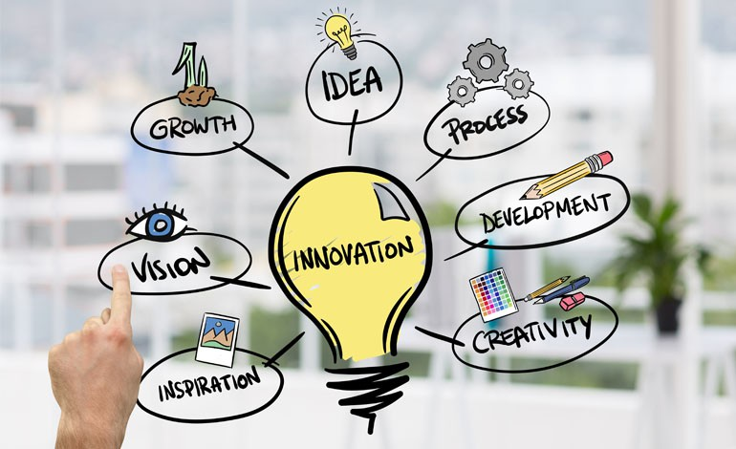

This month, [Allison Mankin](https://gus.lightning.force.com/one/one.app#/sObject/005B0000001xBiPIAU/view), Senior Director of the Public DNS Team, will discuss the technical innovation leadership measures - what exactly is innovation, you ask? A snippet from *Work Psychology* describes innovation as “the intentional introduction and application of processes, products, or procedures designed to significantly benefit the individual, the group, the organization, or wider society.” To be able to embody and innovate at Salesforce - what a great organization to be a part of!

The [Public DNS Team](https://gus.lightning.force.com/one/one.app#/sObject/0F9B000000009QnKAI/view) published its architecture deck for changes coming to DNS services in FY19 (living deck at <https://sfdc.co/publicdnsservices>). The changes will include a Public DNS API Service, and the team committed to its first non-Core customer, the API Team in Marketing Cloud Email Studio, with [Han Zhang](https://gus.lightning.force.com/one/one.app#/sObject/005B0000000MshnIAC/view), Public DNS Engineer, and [Pallavi Aras](https://gus.lightning.force.com/one/one.app#/sObject/005B0000000TrydIAC/view), Lead Software Engineer, demonstrating their prototype.

*Chaos Engineering Spotlight*

The [Chaos Engineering Team](https://gus.lightning.force.com/one/one.app#/sObject/0F9B00000002YGsKAM/view) delivered a big win with their Unplanned GS0 Pod-Level Game Day exercise on December 15th. The exercise was a planned but unscheduled DDoS attack of GUS in order to validate the human response. This accomplishment completed Measure 6, which was to coordinate a blind, large-scale Game Day in Q3. Great work by Shaun Levenson, Zohar Mann, and the team!

**That's it for this month, folks.** Thanks for tuning into this month's CX Newsletter! Want to propose a PCT win for a feature on next month's issue? Submit it [here](https://gus.lightning.force.com/one/one.app#/sObject/0TOB00000009rivOAA/view).